Lab 7: The 555 Timer Chip Monostable Circuit

The 555 timer chip introduced in the last chapter was configured as a free running astable multivibrator or oscillator. A different circuit allows the 555 timer chip to be configured as a monostable multivibrator or single pulse generator. In this configuration, the IC waits patiently for a trigger pulse which when received causes the output to change state for a fixed period of time related to an external capacitor and resistor, before returning to its initial state. The ability of the monostable to generate a single pulse of precise length is often referred to as a 'one shot' circuit element. Many times in digital electronics, a precise delay is required to allow events to be measured, data be displayed for a specific period of time or allow a timing pulse to catch up in order to synchronize events with the clock signal. The 555 monostable is a good solution.

One-shots are circuits that generate a fixed-length output pulse after receiving an appropriate trigger signal. The length of the output pulse is generally determined by the charging of a capacitor through an external resistor. A trigger or start signal sets the output on and initiates the charging cycle. When the voltage on the capacitor reaches an upper threshold level of two thirds of the supply voltage, the output is turned off and the capacitor voltage returns immediately to the initial voltage, zero. The circuit is now ready for another trigger pulse.

Figure 7-1 The 555 Timer IC configured as a Monostable Circuit

The monostable arrangement of components requires only a single resistor and capacitor. The voltage across the capacitor is sampled on pins 6 and 7. A negative trigger pulse on pin 2 sends the output (pin 3) high for a time determined by the resistor and capacitor network. When the capacitor voltage reaches the threshold (2/3 V_{cc}), the output goes low. The on-time Ton is given by
Ton = 1.1 R C. Equation 7.1

LabVIEW Simulation: Operation of the 555 Monostable Circuit

Load the program called Monostable1.vi from the chapter 7 program library. Activate the circuit by clicking on the [Run] button. Click on the trigger switch to fire the monostable. Investigate the on-time by changing the external resistor and capacitor values.

Figure 7-2 LabVIEW Simulation of a 555 Monostable Circuit

In general, the resistor can range from 1KΩ to 3.3MΩ and the capacitor from 500 pf to 10 μF. Thus the on-time can range from microseconds to hours.

The trigger input is normally high and momentarily bringing it low generates the trigger signal. It is important to remember that the trigger input must be brought high again after the triggered low state. For the 555 timer chip, the trigger pulse must be negative and narrower than Ton. Good design calls for a trigger pulse length about 1/4 Ton but shorter times often work well.

A graph of [Output vs Time] figure 7-3 displays the operation of the monostable more clearly. On triggering, the output pulse (shown in red trace) jumps to the high (positive) state and an internal transistor switch (at pin 7) opens to allow the capacitor to charge. The power supply charges the capacitor through the external resistor. The capacitor voltage (green trace) increases 'linearily' from 0 volts to 2/3 Vcc (yellow trace). At this point, the threshold comparator flips state and the internal transistor switch is closed forcing the capacitor to discharge and the output to return immediately to zero volts.

Figure 7-3 LabVIEW Display of the 555 timing voltages

In the simulation, 5 volts was chosen for the supply voltage so that the output is compatible with standard TTL digital chips. However the chip can be run at any voltage from 5 to 18 volts.

LabVIEW Simulation: Triggered LED Alarm
Load the program called Alarm.vi from the chapter 6 program library. A light emitting diode has been added to the output of the 555 monostable circuit. Watch the LED turn on and off, when triggered by clicking on the switch. See the output voltage change and measure the on-time. After activating the circuit with the [Run] button, click on the trigger switch to generate a single pulse.

Figure 7-4 LabVIEW Simulation of a 555 Monostable with a LED Output

The LED is pulled high through a 330 Ω resistor whose magnitude was chosen to limit the current flowing through the LED. In the normal state, the output (pin 3) is low and current will pass through the LED and it will be on. When the output goes high, the LED turns off. A logic probe on pin 3 demonstrates the signal inversion of the LED pulled high.

Photoresistor Sensor
The resistance of a few semiconductors is strongly dependent on the amount of light impinging on the material. For these semiconductors, the energy gap is small enough so the photon energy can excite free carriers across the gap. The result is that current flowing through the sensor can be dramatically altered. The resistance of a typical photoresistor can change by six decades (1:1,ooo,ooo) in going from moonlight to sunlight. The resistance in absence of light, the so-called dark resistance is often in the megaohm region. As the light intensity increases, the resistance falls exponentially. In bright light the resistance is small, a few kilo-ohms or less. A plot of the device resistance versus light intensity displays an exponential variation. Plotting the device resistance as a function of the log of the light intensity displays a linear graph. On a logarithmic scale, the light intensity is measured in units of lux. Zero lux is no light while 10 lux corresponds to a bright flashlight beam. Cadmium selenide, a photoresistance material, has a wavelength or colour response close to that of the human eye. The eye is most responsive to the yellow. These devices make good photometers in photography applications.

LabVIEW Simulation: Photometer
Load the program called Photometer.vi from the chapter 6 program library. In this simulation, one explores the 555 monostable as a light transducer (light is converted into a time interval). Recall that the on-time is directly proportional to the magnitude of the external resistor and capacitor. The charging resistor is replaced with a photoresistor. The on-time ( 1.1RC ) is then a measure of the input light intensity . In this demonstration, the light intensity can be varied from 0 to 10 lux. Investigate the relationship between light intensity and Ton. Click and drag the [Light Intensity] vertical slider marker. To make a measurement click on the [Trigger] switch.

Figure 7-5 LabVIEW Simulation - Monostable Circuit to Measure Light Intensity

LabVIEW Exercise: Plot a graph of the photoresistance as measured from Ton versus the light intensity on a linear scale.
Hint: Convert the lux scale into a linear scale.

LabVIEW Simulation: Angular Displacement Transducer
In the early days of consumer electronics, the Apple II microcomputer used a 555 timer chip to read angular position of a game paddle. Whenever the software instruction INP(0) or INP(1) was executed, a 555 timer chip on input 0 or input 1 was triggered. An internal capacitor with an external potentiometer in the game paddle was used to read the angular position of the game paddle knob. When the paddle was rotated, a new resistance was set. The on-time of the 555 output was measured by counting the number of instruction cycles from the start of the trigger pulse until the monostable returned to the off state. The span was scaled from 0 at one end to 255 at the other end. The angular resolution was approximately one degree per count. It was used to play numerous computer games. With a game paddle on each input, two could play games or the paddles could be used together to plot points on an XY graph such as 'Etch-a-Sketch'.

LabVIEW Simulation: X-Y Joystick
Load the program called XYJoystick.vi from the chapter 7 program library. The two game paddles are simulated using two LabVIEW virtual slide wires. Moving the slide causes a change in the resistance. For fixed capacitors, the on-time is then directly proportional to the resistance or angular rotation of the virtual knob. Two identical circuits have been provided so that both the X and Y motion of a cursor can be controlled. Note the variation in T_{on} for each channel as the slides are moved. The on-time is scaled to produce a number from 0 to 255.
Figure 7-6 LabVIEW Simulation - Joy Stick Operation using a Monostable Circuit

LabVIEW Challenge: Capacitance Meter

Design a LabVIEW simulation to demonstrate how a 555 Timer IC can be used to measure capacitance.

Hint: The capacitance is unknown and can vary over many decades. Choose a series of resistors of the same mantissa but different multipliers. For example: 1 kΩ, 10 kΩ, 100kΩ etc.
eLab Project 7

Objective: To study the application of a 555 Timer IC in a triggered alarm circuit.

Procedure: Build a monostable circuit based on the front panel Alarm.vi, figure 7-4. Connect a 330 Ω resistor and red LED to the output (pin 3). Set R = 5.0 MΩ and C = 1.0 μF. A pushbutton is used as the triggering device. Each time the trigger is pushed, the output (pin3) goes low for a specific period of time. In order to invert the 555 output, a TTL buffer chip 7406 has been added. Its output (pin 4) now only goes high when the switch is triggered and stays high for the time set by the monostable circuit. The component layout is shown below.

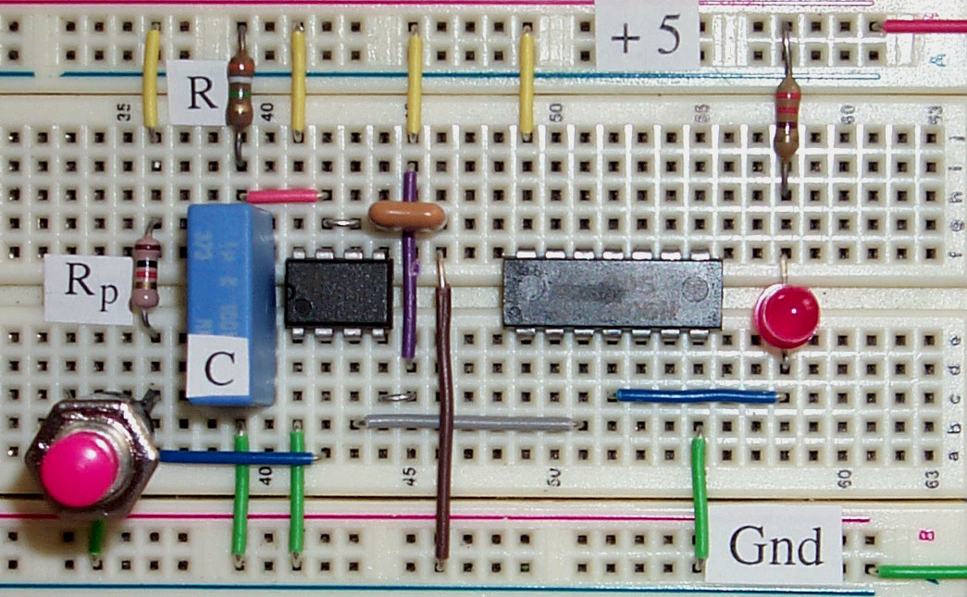

Figure 7-7 Component Layout for Triggered Alarm 555 Timer Circuit

Notes: 7406 is a TTL Hex Inverting Buffer
Input for Inverter No.2 is pin 3,
Output for Inverter No.2 is pin 4,
Power +5 volts is pin 14 and Gnd is pin 7

Computer Automation 7 : Measuring Time Interval

The monostable circuit of eLab 7 produces a pulse of fixed length each time the 555 timer IC is triggered. All information about the circuit is contained within the pulse length. In this lab on computer automation, a time interval counter is used to measure the pulse width.

Launch the program Pulse Width.vi from the program library of chapter 7. Note that some connections are require on the output of the DAQ card. Connect the output of counter0 to the clk or source input of counter1. Connect the output pin 3 of the 555 timer chip to the gate input of counter1.

Note: If you are using the DAQ card with the AMD9513 or DAQ-STC counter/timer chip, then use Measure Long Pulse Width.vi from the AMD9513.llb or DAQ-STC.llb library.

Pulse Width.vi has a variable time limit. If during this time a pulse is detected then the pulse width is measured and the VI stops. If no pulse is detected, the VI stops after the time limit and a Boolean LED display is lite. Set the time limit to at least 10 seconds.

Run the program by clicking on the [Run] button. With the program running, now generate a trigger signal by momentarily pressing on the push button of eLab 7. Pulse Width.vi will report on a front panel, the width of the pulse generated by the 555 monostable circuit. Observe how the measurement accuracy depends on the timebase.

Circuit Enhancements

Replace the resistor with a variable resistor in the range 10–100 kΩ, and investigate the changes in pulse width as the resistance is changed.
Replace the capacitor with a variable capacitor in the range 0.05–1 μf, and investigate the changes in pulse width as the capacitance is changed.

LabVIEW Enhancements

Design a LabVIEW program which continuously monitor the 555 monostable circuit and reports the pulse width of each pulse generated by the trigger signal.

